- Ashish - Teacher profile photo sentence:
Upload an image in .png or .jpg max 800px
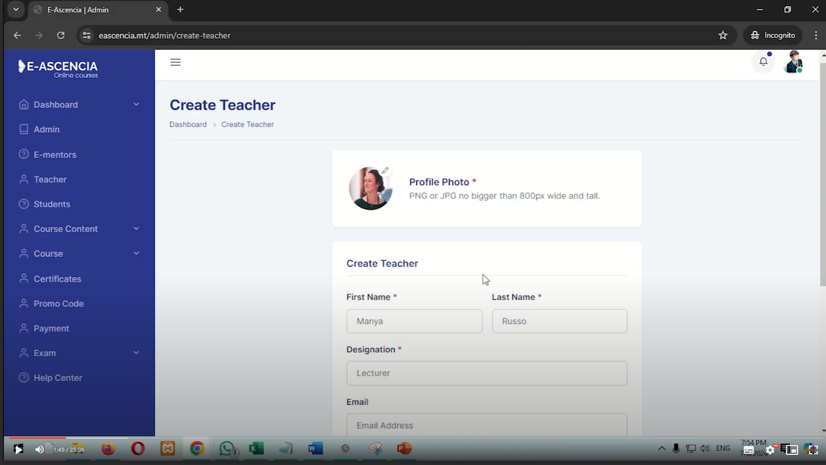

- Course details page
There shouldn’t be cut out words showing;
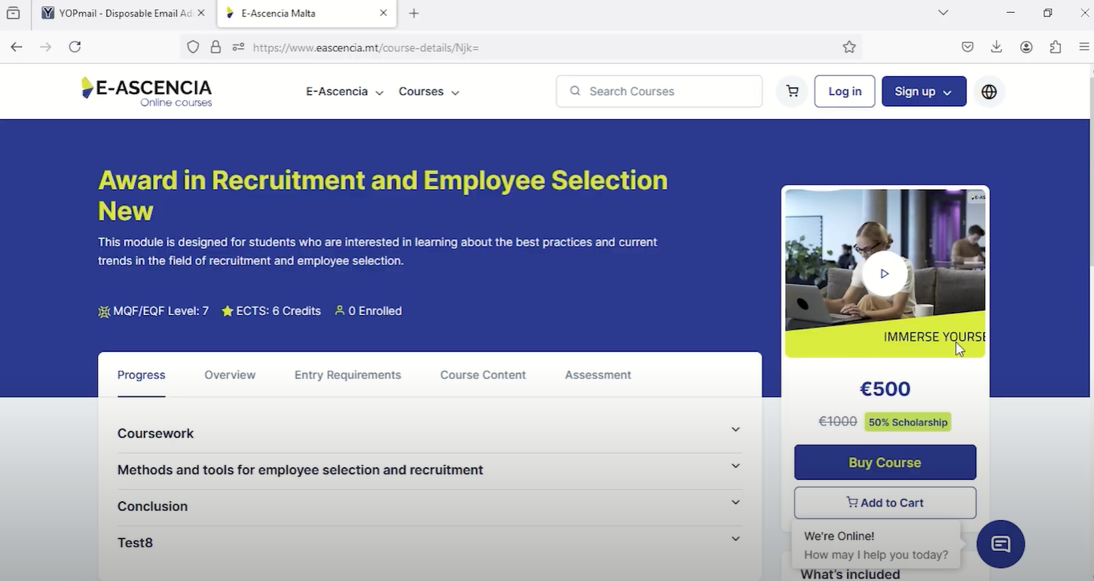

- What’s included
  - Haresh - Make sure the number of lectures is correct:
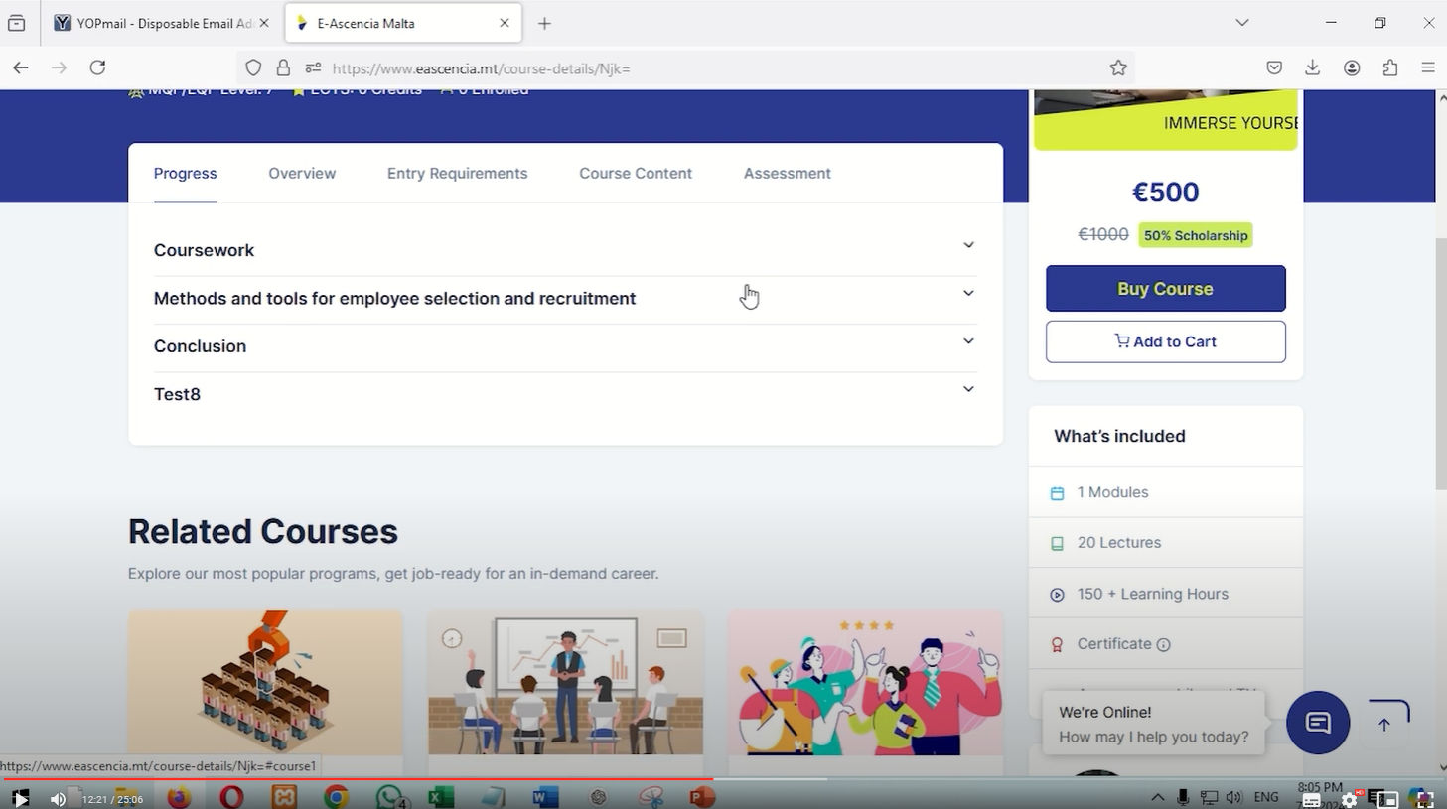

3. Pranil - Customer Support:
Replace second line with: How can we assist you?
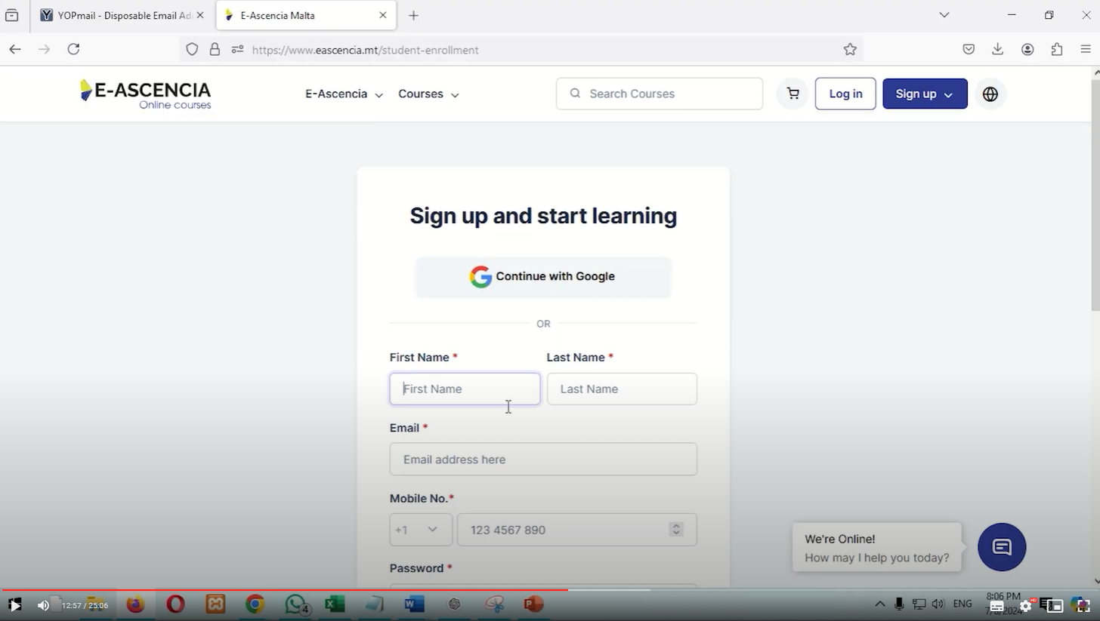

4. Ashish – Student profile – customization
- Change functionality to optional not mandatory and change sentence to – About you
- Also, & include that this can be seen by the admin team and e-mentors

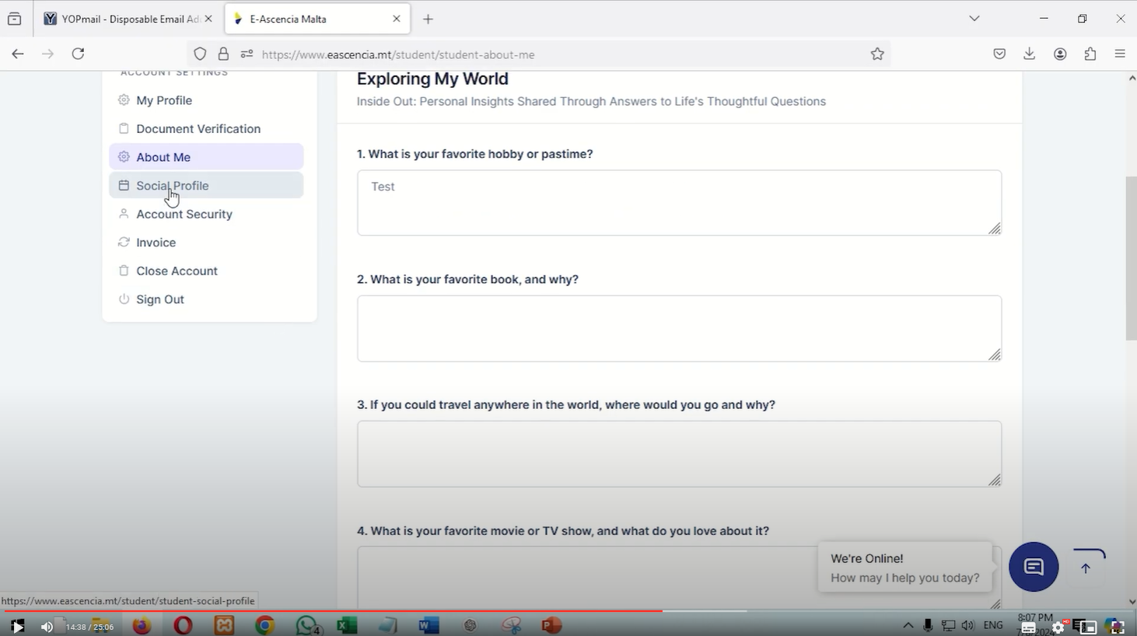

5. Ashish – Student social profile
- Change to non-mandatory & include that this can be seen by the admin team and e-mentors
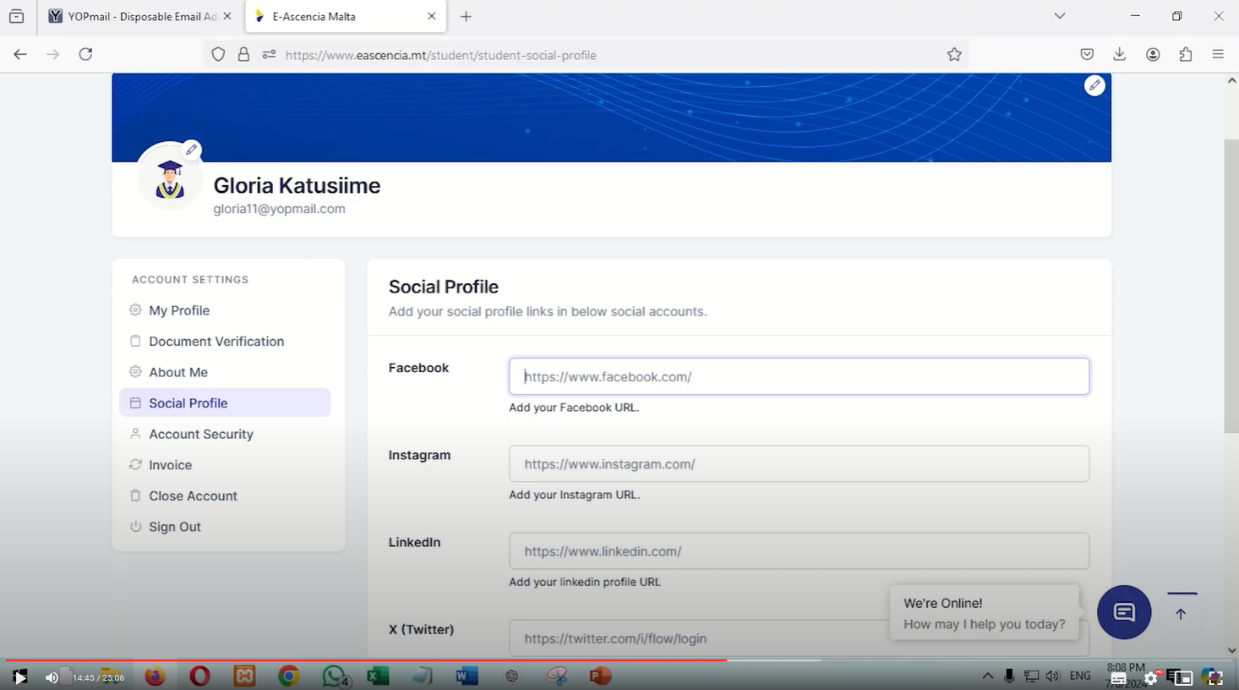

6. Ashish – student Log out page
- change the writing to Successfully logged out
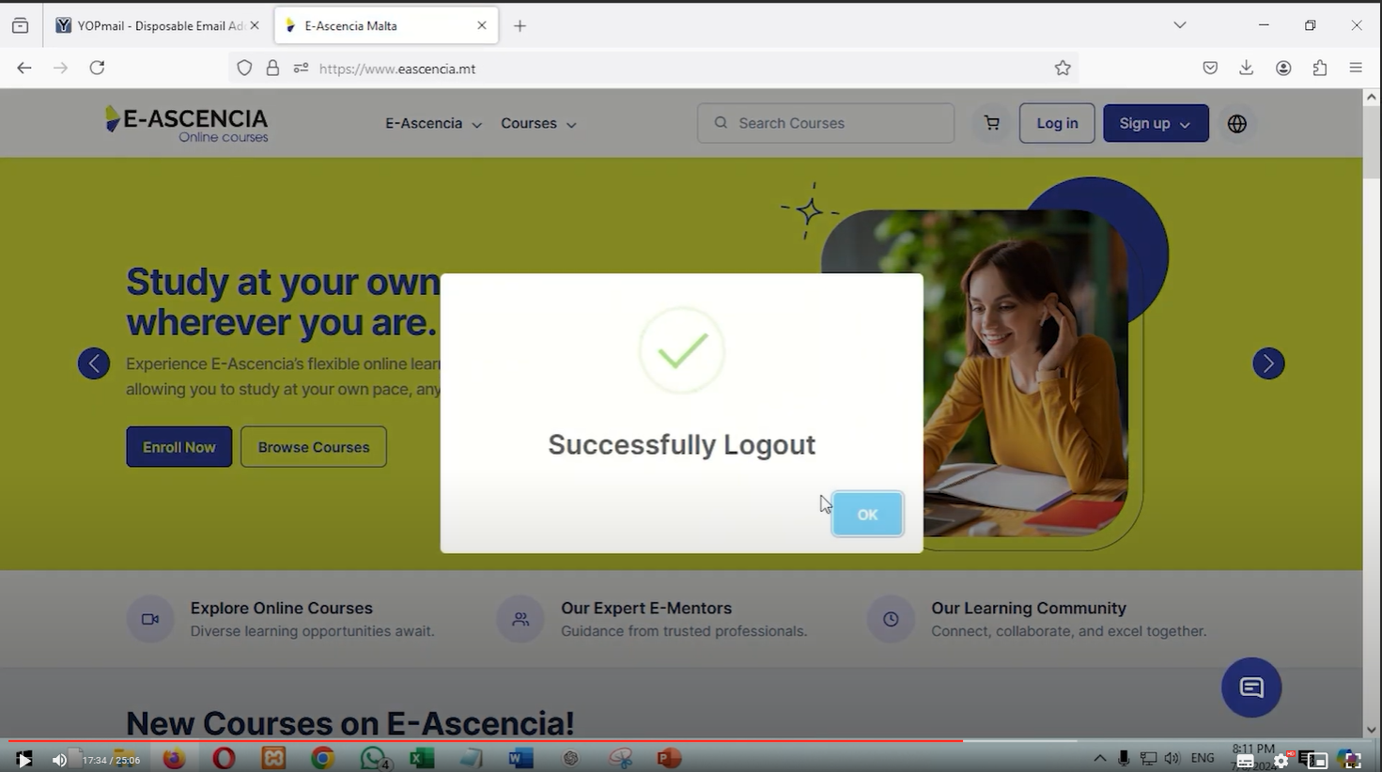

7. Ashish – Course Page – Front end
Remove students enrolled:
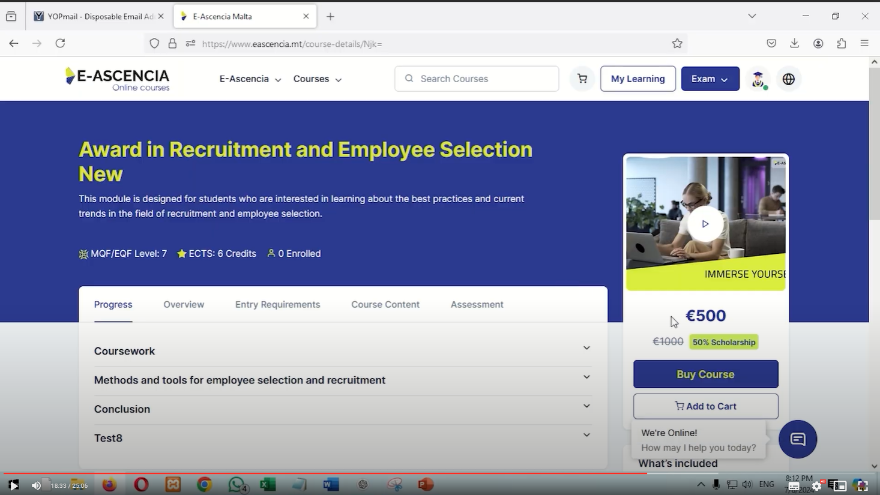

8. Ashish – Remove from cart – frontend
Change wording to: Successfully Removed This item has been removed from your cart.
Icon: should be a ☑
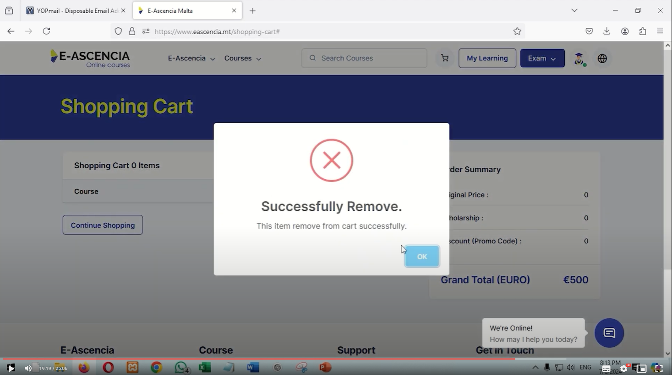

9. Ashish – front end – empty shopping cart
- change the second line to just Your cart is empty!
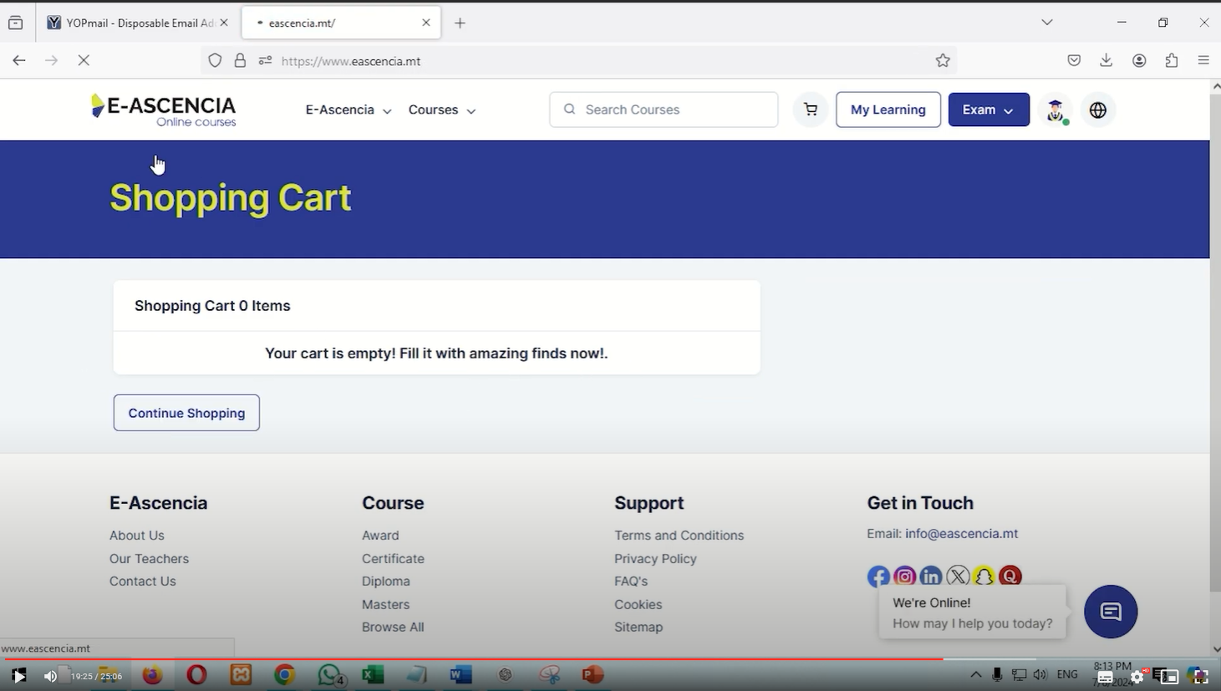

10. Ashish – front end – display bar
- Should read only E-Ascencia

11. Ashish – payment checkout page
- change wording to: Securely save my details
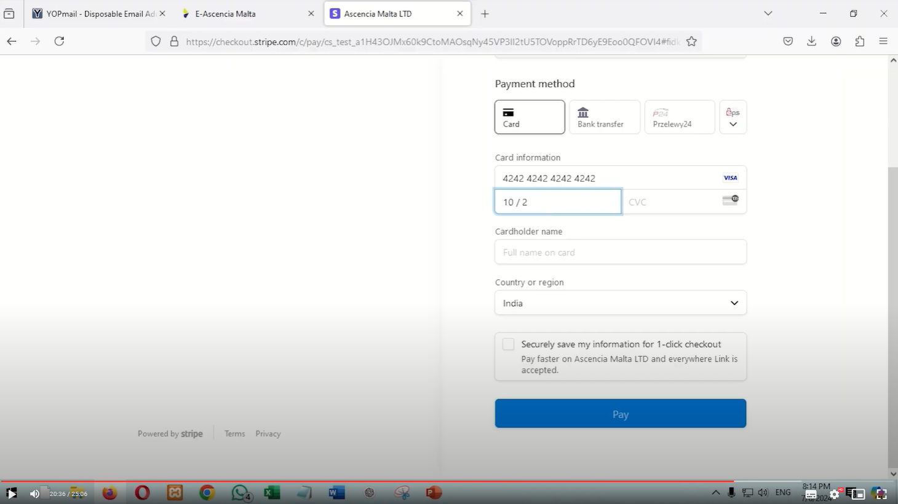

12: Ashish – Close Account
- Change wording to: Are you sure you want to permanently close your account?
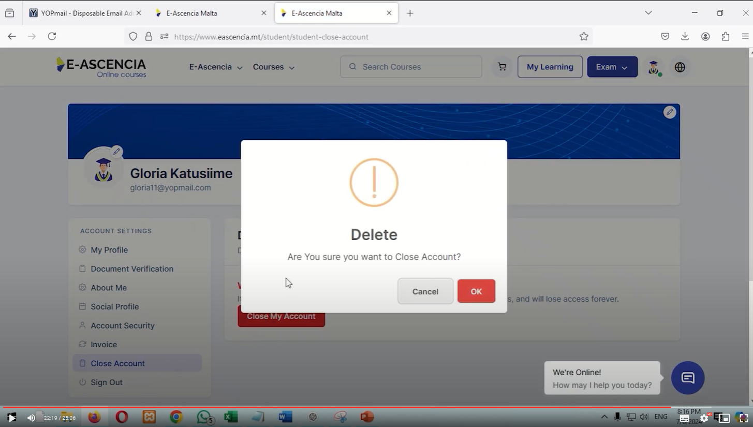
13: Ashish – Close Account
Change wording to: Account Closed
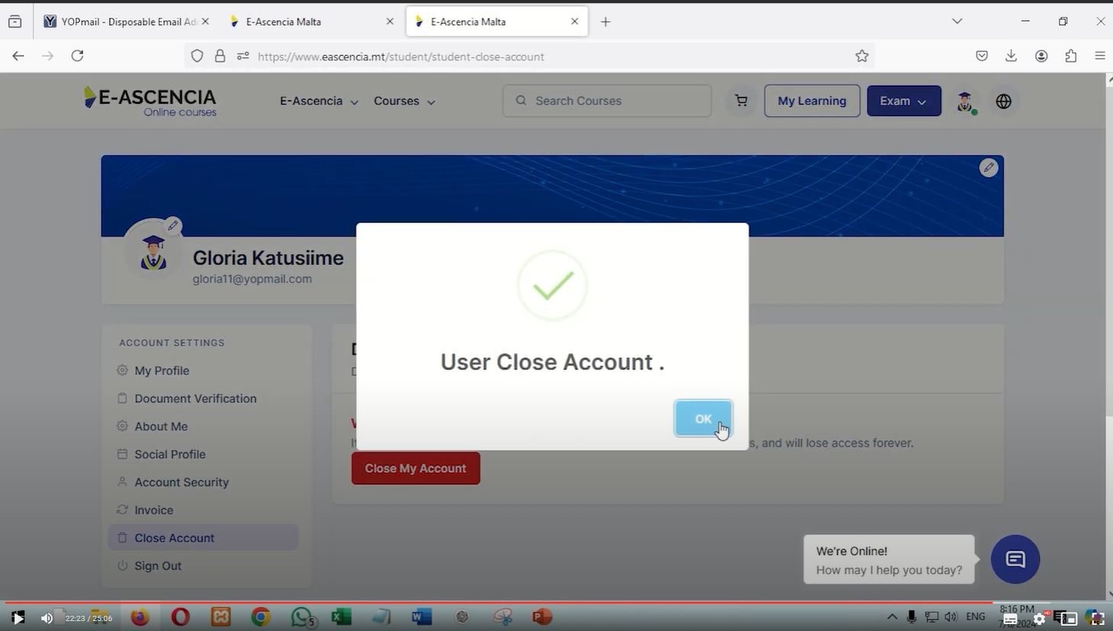

14. Haresh - Email templates
- What happened to the nice versions we designed?
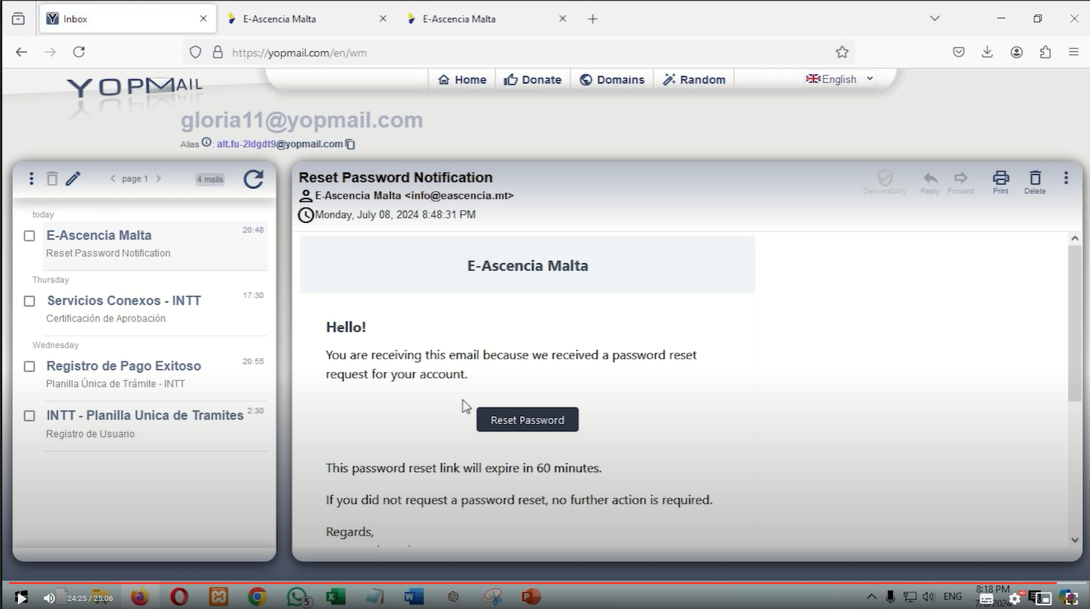

15. Aftab – Security testing
- Aftab what can we do please do avoid getting the notification below? Chetan, can you test on other mail platforms too please?
