ERP Dev Ascencia Malta
  - Admin Access

General Points:
- It’s recommended to make long dropdown lists searchable in every page for better user experience.
- It’s recommended to use a consistent format for all validation and error messages throughout the panel.
- Implementing tooltip notes at key points in the system can help guide new users and improve their understanding of the features.
- Display non-editable fields as disabled to ensure users can easily distinguish them from editable ones.
- Ensure that when one module depends on another, the main module is placed before the dependent one. For instance, place “Course” before “Modules” in sidebar.
- Ensure that all Date and Time input fields across the portal use a Uniform Format for consistency.
- Profile title like Teacher or Visa Team or Accountant can be displayed in Sidebar after Logo, that way it appears all time.
- Is there any actions log maintained inside system, like created by, created datetime, updated by, updated datetime, deleted by, deleted datetime etc.
- Providing an Excel/CSV import feature for bulk data input will make the process faster and easier for users, helping them save time and minimize manual work.

Forget Password:
- From admin panel, 1 accountant user created with
UserName: AbdulRahim
Email: abdulrahim@angel-portal.com
And then deleted/deactivated the same, again created a new accountant with
UserName: AbdulRahim2
Email: abdulrahim@angel-portal.com
And system let this new accountant create with same email but with different UserName but, when try to Forget Password as shown in below image, it throws error.
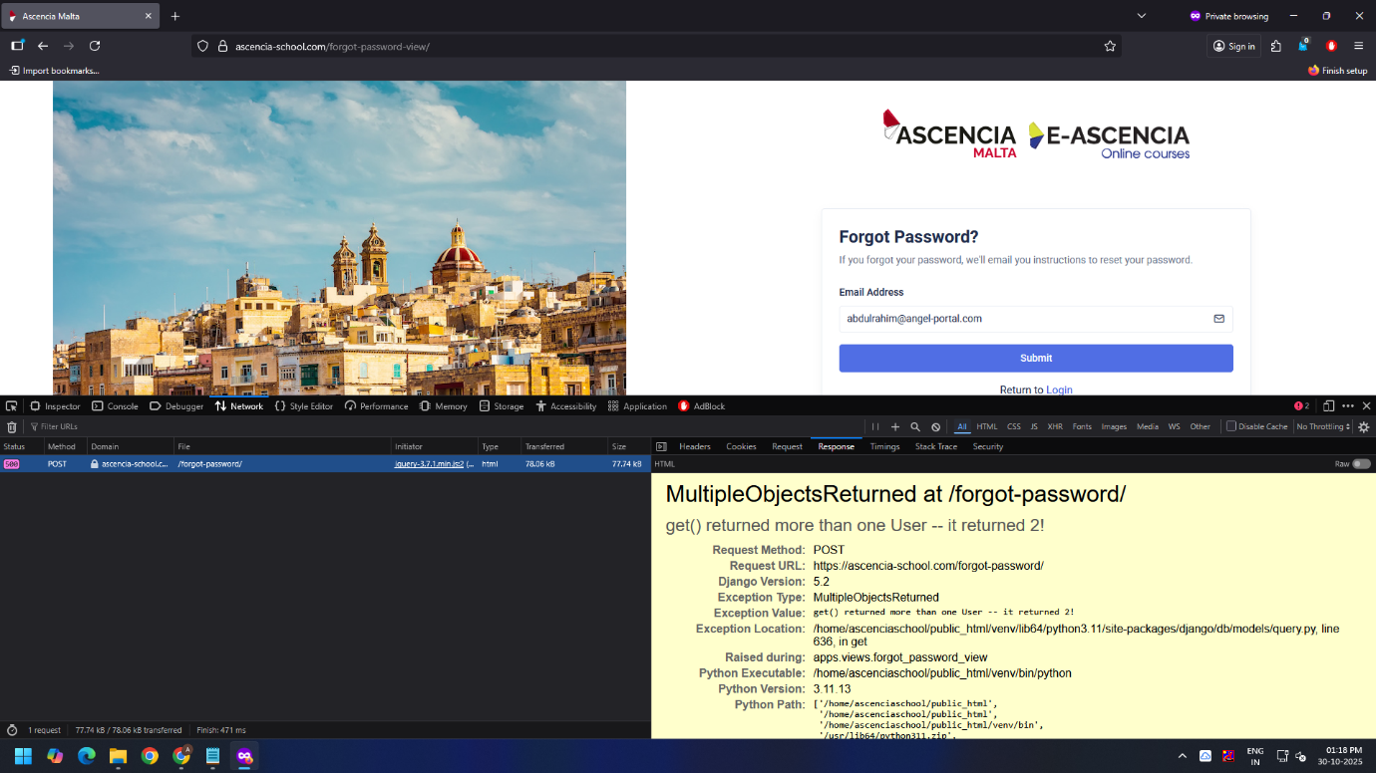

User Dashboard > Account Team List:
- On deleted/deactivated user, user get removed from the list, but there is no deleted/deactivated users list. Creating filter for active/inactive users will enhance the user experience and ease the work.
- Note: Unique while creating new users: UserName and Email

User Dashboard > Librarian List:
- In librarian edit modal form the UserName is last input whereases in other forms its 3rd input box, kindly align form fields.
- The same mistake of UserName present in Administrator edits form.

User Profile Update:
(Account Team List, Visa Team List, Teacher List, Student List, Librarian List, Administrator List)
- In “Edit Personal Information” form, if fields are not editable then display them as Disabled (it creates confusion if it appears as editable fields).

User Dashboard > Student List:
- In “Students List”, the Student Owner Akshay does not appear in Student Owner Select Box as shown in below screen shot.
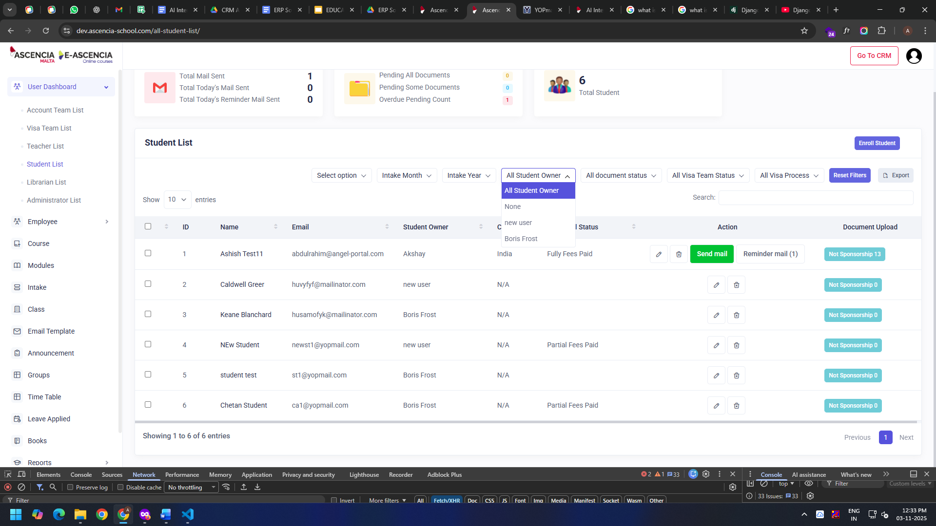
- Suggestion: Column title Fees Paid Status can be change to Fees Status
- In Student details section form Admin login, Document type is not visible, check below image, there are uploaded document file name, date & time, size and action, to check which document has uploaded by student it requires to view, there should be title which identifies the document type.

- 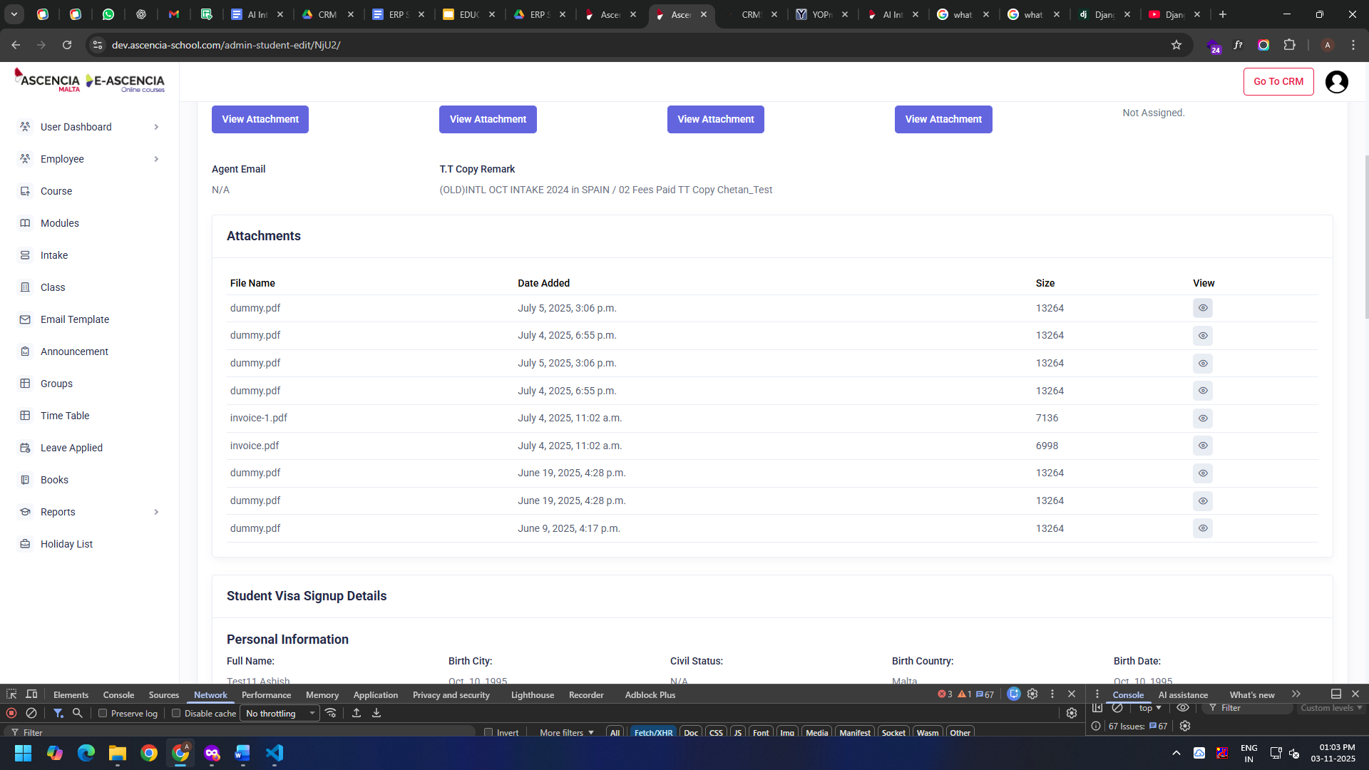

Employee > Employee List:
- There is no employee status column or option, it is recommended to have employee status.

Leave Applied:
- Note: In leave section, if someone approved a leave and then for some reason management decides to cancel the leave, how those requests can be handled in the system, because as of now there is no option visible.
- In leaves list, if the leave reason is large, not able read complete reason, making text flexible.
- It is recommended to add filters for searching leaves, Start Date, End Date, Person etc.

Books:
- In books section, once book is created, it redirects the user on main list page, but DataTable error appears on top, check below image.
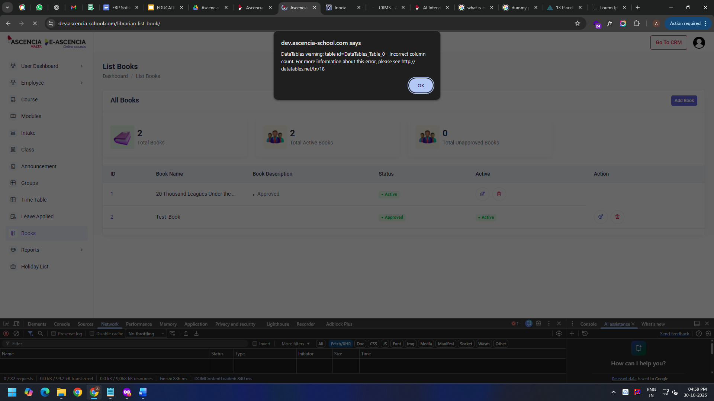
- In books section, it is observed that once a new book added, it appears as Unapproved and Inactive.
Suggestion: Once new book is created it should be active by default but, these books should be Unpublished (not Approved/Unapproved), and there should be provision to Publish / Unpublish with logs e.g. Created By, Published By, Unpublished By etc.
- When librarian add a new book, it gets added with status “Unapproved” but, to approve it Admin has to Update the book, there is no provision of Approve / Reject or Publish / Unpublish.
- The list column name should match their description e.g. Status column should be Publication Status and Active column should be Status (as used in other lists).

If you require to be even more precise depending on use case, here are some alternative label sets:
Purpose | Column Name | Possible Values
For Admin view | Approval Status | Approved / Pending / Rejected
For Visibility | Publication Status | Published / Unpublished
For System State | Status | Active / Inactive

Time Table:
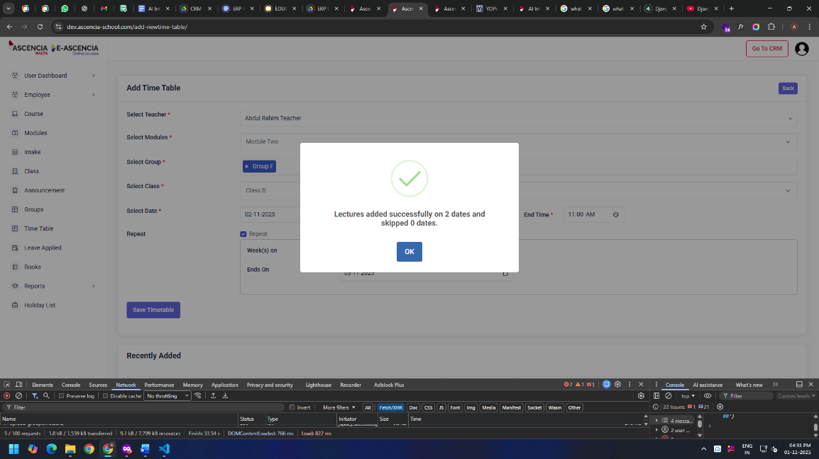
- When new time table added, the success message is not clear, check below image

- Update Time Table: there is no option to change the Repeat Selected Days and Date.

ERP Dev Ascencia Malta
  - Accountant Access

Apply Leave:
- In leaves list, if the leave reason is large, not able read complete reason, making text flexible.
- Once the leave is submitted, reset the form.
- Submit Leave & Cancel button require some space in between, currently looks squashed.

ERP Dev Ascencia Malta
  - Teacher Access

Book List:
- In book list, the description column can be shrunken down with fixed width, so that horizontal scroll will not appear, it taking too much unnecessary space.

ERP Dev Ascencia Malta
  - Employee Access

Attendance:
- When “Punch In” from Employee login, below error occurred, check and rectify.
- Note: the employee created from
