CRM- Student Owner
1.Dashboard- Superadmin dashboard displayed- Required respected owner dashboard
2. Agents- Self displayed but
* When Mob no. not added- ND,
*Location- Not displayed
*Profile photo- When added or not added- All places required same profile photo
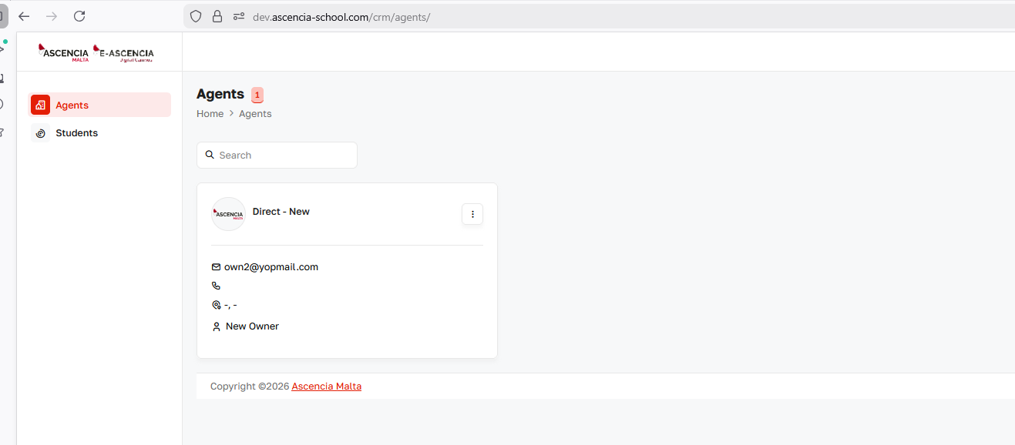
1. Edit- When self agent- Not required to edit option
2. Add contact- When self agent- Not required
Add Agent- Replaced company by Agent
